***Aim***

To design a system for home security systems, such that whenever someone approaches the gate, the LED starts blinking once every 100ms

***LEARNING and OBSERVATIONS***

The instructions are given to the audrino Board by performing in the computer. The language used in this experiment in c Audrino is used to make the applications more accessible which are interactive objects and surroundings. It provides the genuine instructions to the elements placed in the breadboard according to the programming done in the software. The security system works on the simple concept of securing entry points into the home with the sensors that communicate with the control panel or command center installed in a convenient location somewhere in the home.

PRECAUTIONS

1.Take care that the programming because the wrong programming can cause problems ijn the software

2. Make sure that the wires and connections are properly connected and are tight.

3. the order of positive and negative terminals should be correct.

***PROBLEMS AND TROUBLESHOOTING***

1. Perform the practical after having some practical after having some practices the concept of programming language deeply.
2. Place the hardware properly or use the hardware (breadboard) properly.
3. Check the wires before executing the program. Make sure that the connections are tight properly.

***CODING***

int sensorState= 0;

void setup():

{

pinMode( 2, INPUT);

pinMode(13, OUTPUT);

Serial.begin(9600);

}

void loop () {

sensorState== digitalRead (2);

if (sensorState == HIGH)

{

digitalWrite(13,HIGH);

Serial.println(" Sensor activated!");

}

else

{

digitalWrite(13,LOW);

}

delay(100);

}

***CIRCUIT DIAGRAM***

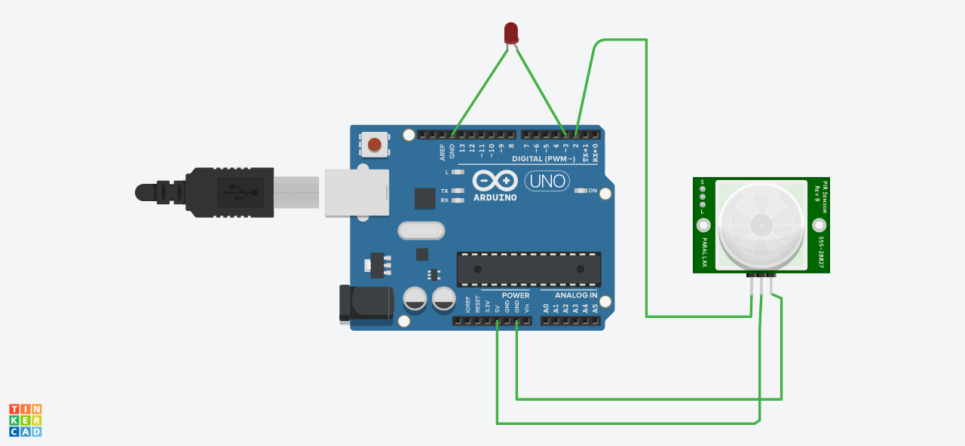

***LEARNING OUTCOMES***

From this experiment we get to know how to make an LED home security system and got very deep information about the working of control panel , circuits and audrino programming